Suricata

Examining logs with Suricata

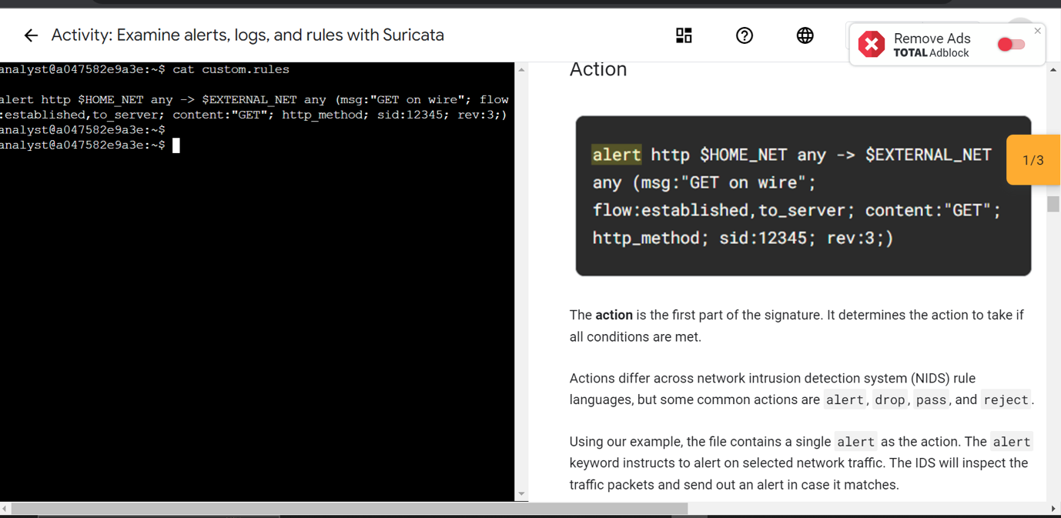

Custom rules with suricata

Chronicle

